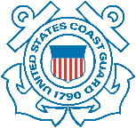
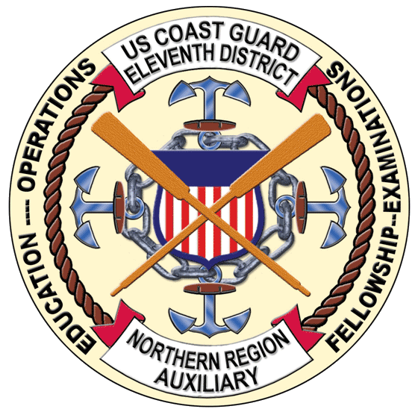
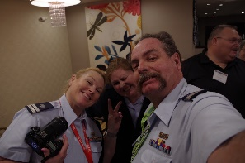
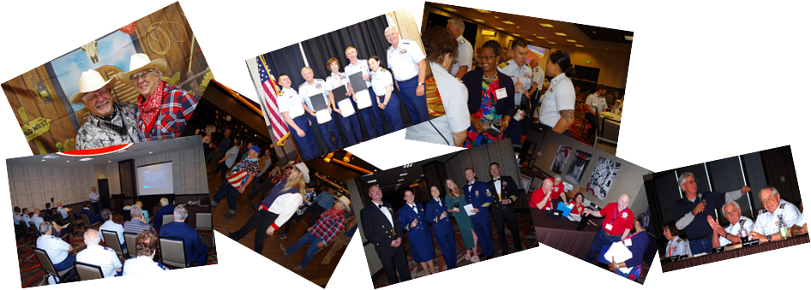
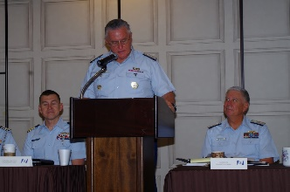
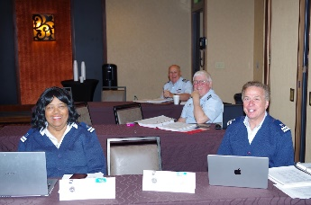
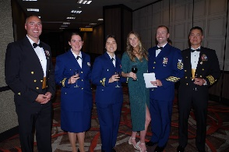



Fellowship
Lunch &
Dinner
National
Updates
Training
DTRAIN 2025
SAVE THE DATE
Coast Guard Island (CGI)
Alameda California
Fellowship
Recognition
Awards
Coast Guard Base Alameda
YOU DON’T WANT TO MISS DTRAIN!
SATURDAY JUNE 21, 2025
UNITED STATES COAST GUARD
AUXILIARY DISTRICT D11N

