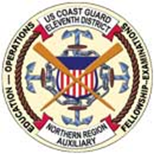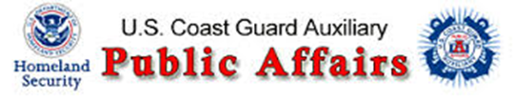
District Board and Staff Meeting January 2017
BOARD MEETING PHOTOS – Roger Bazeley, USCGAUX Public Affairs D11N
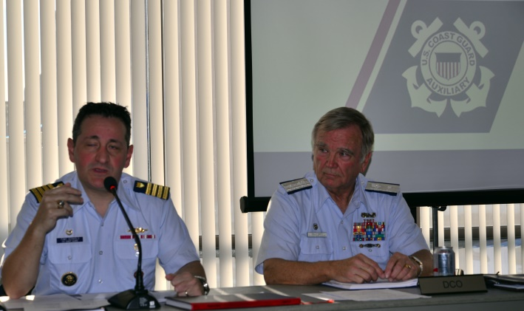 | 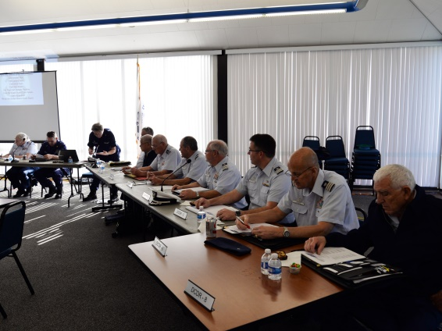
D11N District Meeting – PCA Training Fair Newly Elected Officers – CMO D11N Wally Smith
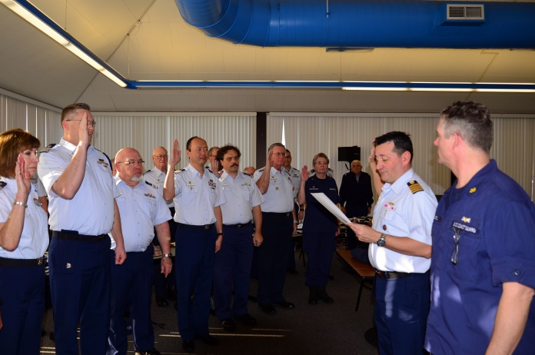 | 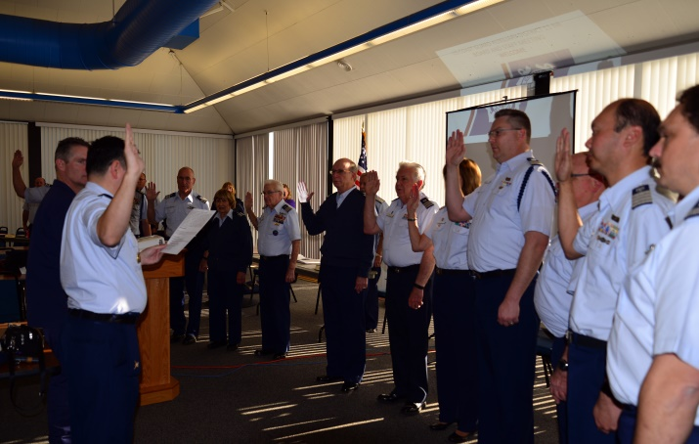
Swearing In of Newly Elected 2017 District Officers by USCG Captain Ceraolo
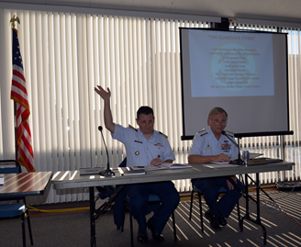 | 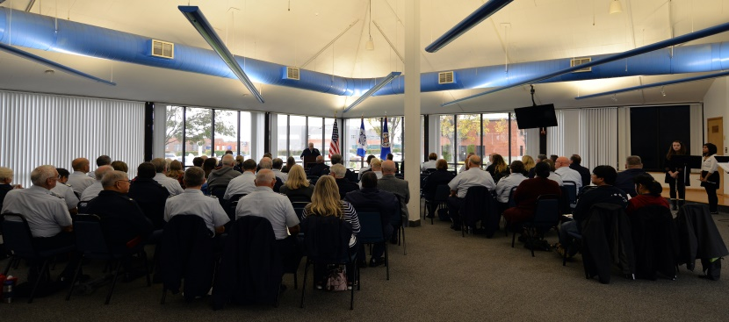

District Board and Staff Meeting January 2017
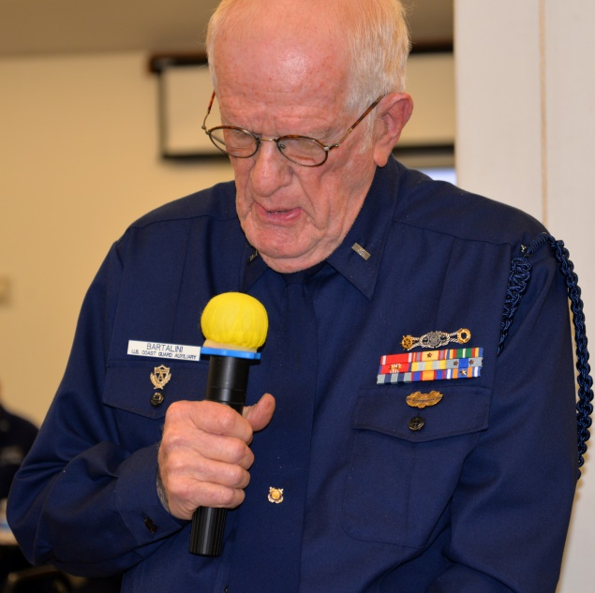 | 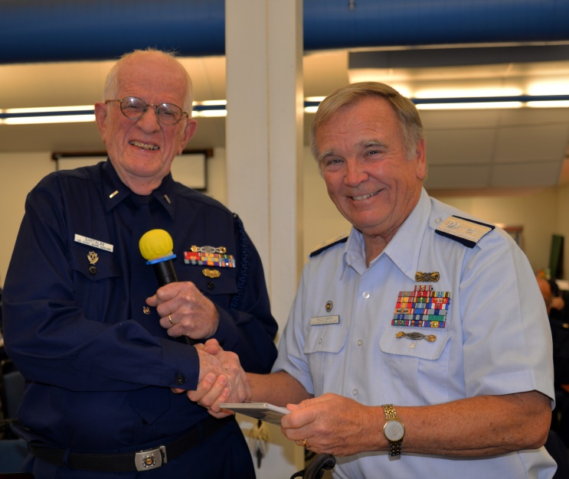
Auxiliarist Bartalini Giving Report on D11N Honor Guard’s Participation in the Pearl Harbor 75th Remembrance Anniversary Parade in Honolulu. Memento Presented to COMO Wally Smith

D11N Honor Guard at Pearl Harbor 75th Anniversary Parade, Oahu Dec 7, 2017-Roger Bazeley
Various National events were supported by USCG Auxiliarists including 16 members of the D11N Honor Guard who traveled to Honolulu for commemorating the 75th anniversary of the Japanese attack on Pearl Harbor. Auxiliarists Duane L. Blackwell and retired Superior Court Judge Chester Richard Bartalini were among those who participated in the “National Pearl Harbor Remembrance Day Parade” held in Honolulu including active duty Coast Guard members Cmdr. J. Andrew Williamson mentor and Honor Guard Instructor and Lt. Ernest “Ernie” Saponara. The USCG Auxiliary Honor Guard’s District 11 North, encompasses Northern California, Nevada and Utah.
The total list of participating USCG Auxiliary D11N Honor Guard members consisted of four sentries and twelve banner and flag carriers marching in the Honolulu National Pearl Harbor Remembrance Parade were: HG Captain Tracy Schultz, HG Captain Elect Chester R.Bartalini, Chief Duane Blackwell, Rick Scheuerman, Geoegie Scheuerman, Tamara Badano, Michael Badano, George Rogers, Steve Bustin, Karen Yoder, Kathy Boyle, Jerry Gillgren, Scott Cassell, District Captain Christopher Ware, Gold Side members, Commander J. Andrew Williamson & Lieutenant Ernie Saparno.

D11N Honor Guard at Pearl Harbor 75th Anniversary Parade, Oahu Dec 7, 2016
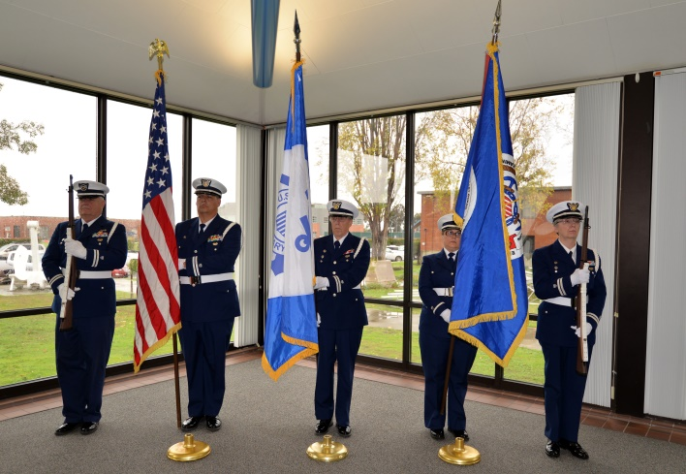 | 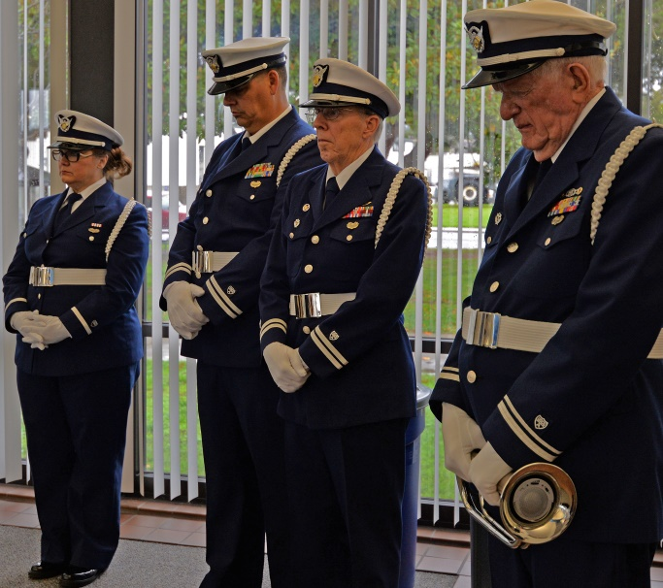
D11N Honor Guard at Auxiliary 2016 Annual Remembrance Day – Chester Bartalini, Bugler, who also participated in The Pearl Harbor 75th Remembrance Parade Photos: Roger Bazeley USCG-AUX PA
The D11N Honor Guard has participated in Alameda’s Fourth of July Parade, San Francisco Veterans Day Parade and the Fresno Veterans Day Parade. Other events the honor guard has participated in include: various memorials, changes of watch, retirements, ship christenings, Memorial Day services, professional sporting events Santa Cruz Harbor’s 50th Anniversary and other special ceremonies
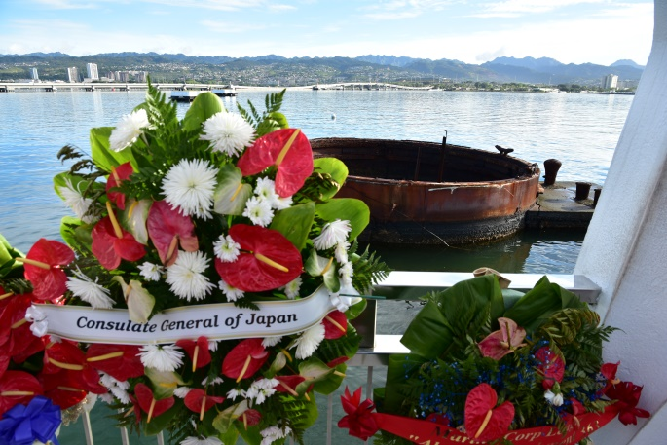 | 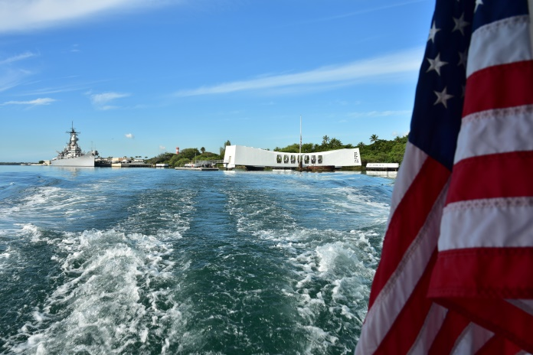
Pearl Harbor, Honolulu USS Arizona Memorial Visit – Photos: Roger Bazeley FSO-PA D11N
December 8th USS Arizona Memorial Visit at Pearl Harbor, Honolulu Hawaii

January 2017 D11N Meeting – Chester Bartalini’s Memorable Pearl Harbor Report
Chester Bartalini D11N Honor Guard Sentry and Bugler – Report “The Experience of a Lifetime”
“On December 7th 2016 the District Honor Guard had the pleasure and honor of participating in the National Pearl Harbor Remembrance Day Parade commemorating the 75th anniversary of the Japanese attack on Pearl Harbor. Our team has participated in many events including Memorial, Changes of Watch, Ship Christenings, Memorial Day Services, Professional Sporting Events (Oakland A’s, Forty Niners, Bulls), Veterans Day, and 4th of July Parades and various Auxiliary District meetings and training events.
Each event provided us a degree of satisfaction and pride in being asked to do so. But none of those events, individually or collectively, provided us the thrill and satisfaction as did our marching in the Pearl Harbor Parade. The emotion was almost overwhelming. Being in the presence of a survivor of the Arizona sinking and a number of survivors of the attack in general was without doubt an emotional experience of a lifetime. Our team consisted of four sentries and twelve flag and banner carriers. We led a platoon of sixty regular Coast Guard members, who in turn led the nationally renowned U.S. Coast Guard Precision Silent Drill Team. Combined, we were an impressive entry.
I am in my 86th year and was a preteen during World War II. Because our father was a shipwright working at Moore Brothers Dry Dock building warships of one kind or another, our mother was a volunteer with the Red Cross Canteen Services, air raid practice at school, blackouts and rationing. I had some understanding about what was going on in Europe and the South Pacific and the sacrifices those who were fighting were making.
But until my participation in the Pearl Harbor Parade, I never had to my memory, the opportunity to say Thank You. Thank you, to all those who gave their lives so that I could enjoy all privileges and opportunities I have had in those 86 years. Saying thank you in such a momentous atmosphere as the Parade provided has given me a degree of satisfaction that I have made a down payment on a debt I will never be able to satisfy in full (Chester Richard Bartalini; Captain Elect U.S. Coast Guard auxiliary Honor Guard District 11 North).”
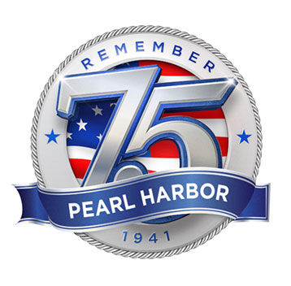 | 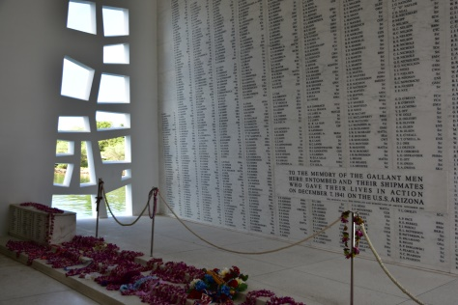
USS Arizona Memorial Wall of Names of the Fallen – Dec 7th-2017

